1. 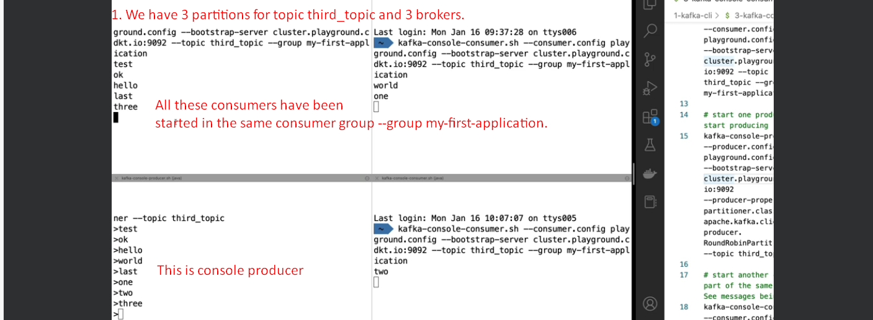  
   Starting and removing consumers from a group will trigger rebalancing the assignment of partitions.
2. If we have more consumers in a group than total partitions, then those extra consumers will be sitting there idle.
3. Let’s stop all the consumers in the group first_group, then produce msgs and restart the a new consumer within the same group, what happens?  
   A screenshot of a computer

   Description automatically generated
4. A screen shot of a computer

   Description automatically generated
5. A computer screen with red text

   Description automatically generated  
   --from-beginning works only for new groups.   
   For old groups, we will be reading from where the consumer offsets were last committed.